How I got blogging in 2022

So I found a super cool web-designing application that used markdown to design the webpages.

[NuGet Gallery | retypeapp 2.4.0](https://www.nuget.org/packages/retypeapp)

This looked great for a documentation website I wanted to build. So step one for me was to make that into a powershell module which I did and this is available here:-

[PowerShell Gallery | Retype 1.0.4](https://www.powershellgallery.com/packages/Retype/1.0.4)

So I install the module, then check the cmdlets available as I always do in modules (even ones I create myself)

So I want to **Install-Retype** but will need to launch the pwsh as an administrator. So as I installed and created this module on my trusty x86 machine you need to take note of the URL you need:-

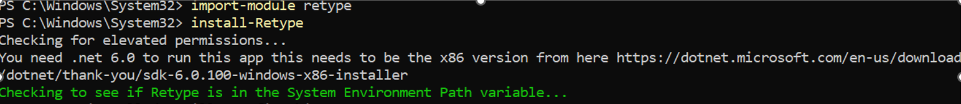

This then adds to my variable path what I need, but I need to download:-

<https://dotnet.microsoft.com/en-us/download/dotnet/thank-you/sdk-6.0.100-windows-x86-installer>

So after you have installed the required .NET as mentioned above, and run the **Install-Retype** having pwsh launched as an Administrator, you are now ready to get rocking with your first project

Oh no I get an error, I obviously didn’t do a great job when building this module, but to fix this error, I just need to NAVIGATE to where the module is installed:-



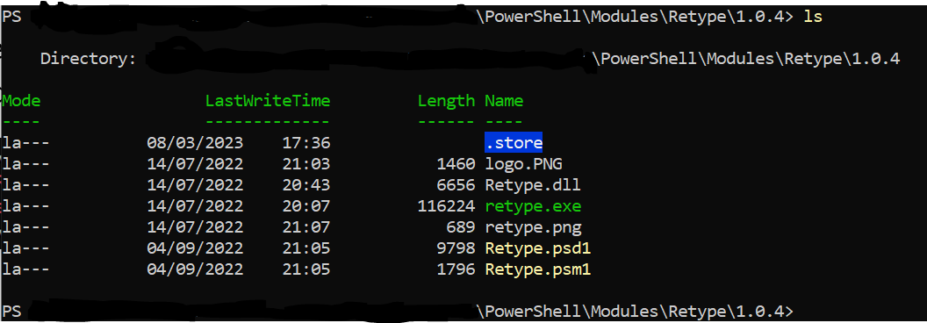

So I can see the retype.exe is located where I installed the module. So lets try to initialize a project again. But I need to close pwsh as the administrator session and start a new pwsh launch as me. I created a folder in C:\blogSite

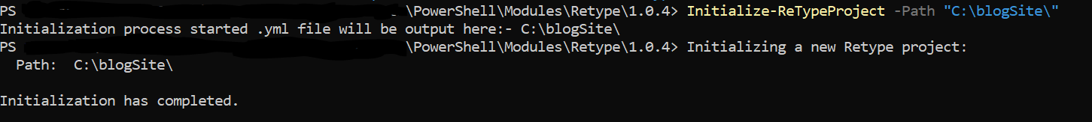

Great so this looked like this worked, all I had was a completely empty folder, so now lets have a butchers at what is now inside this folder…

One .yml file now exists in this directory. So this is referred to in detail here:-  
[Project configuration - Generate, publish, and share documentation (retype.com)](https://retype.com/configuration/project/)  
This is your personal project configuration file you will need to tweak. Once you have initialized your project successfully and edited your project configuration .yml file, you are now ready to get building your website.

So within the same folder my C:\blogSite directory, I then created a demo page using the code provided here:-

[Page configuration - Generate, publish, and share documentation (retype.com)](https://retype.com/configuration/page/)

I just needed to then issue

To get my site built. If I just wanted to preview how the site looked before building it, I would use the **Initialize-RetypeWatch** command, which would preview the site, and allow me to make on-the-fly changes to the script and see the page updated. I hope this helps you in building your site.